4 week Summer Splash
GET FIT, GET WET
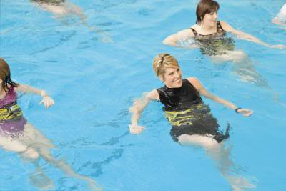
Tuesdays & Thursdays @ 7pm,
(mixture of endurance training & strength training in shallow and deep end of pool)

Swimming is not a requirement

(Flotation Belts available)

Classes start August 3 and end August26

Cost: Members of Valdese Rec $20
Non Members $33
LIMITED to 18 participants, need a minimum of 10

Must SIGN up and PAY at Fitness Desk by July 30
Sign-Ups start Monday July 5th
Valdese Recreation Center
Instructor: Toni Reece

