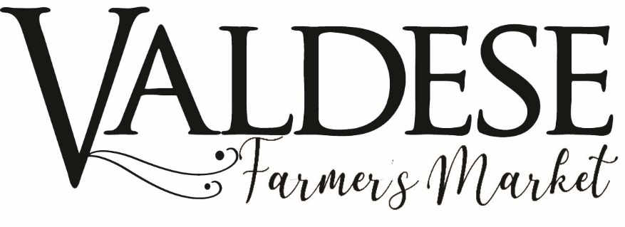
VENDOR APPLICATION
FRIDAYS MAY 24-AUGUST 30•11AM-4PM•Old rock school lawn
CONTACT INFORMATION
Owner Name: __________________________________ Farm Name: ____________________________________
Mailing Address: ___________________________________________________________
City: ________________________ State: ________ Zip: ________________County: _________________
Physical Address:______________________________________________________________
City: _________________________________ State: _________ Zip: ________________
County: ______________ Telephone: __________________________________
Email: _____________________________________________
PRODUCTS
Provide a complete list of the products you will sell at the market. Include produce, flowers, baked goods, and any other item that is strictly hand made. ____________________________________________________________________________________________________________________________________________________________________________________________________

BUSINESS SUMMARY
For marketing purposes, please briefly describe your farm/business. If you have pictures, please attach or email. ____________________________________________________________________________________________________________________________________________________________________________________________________

Old Rock School Front Lawn
400 Main Street West
PO Box 339 Valdese NC 28690 P: 828.879.2129 W:townofvaldese.com
LICENSE, PERMIT, CERTIFICATION & INSPECTION REQUIREMENTS
Vendors are required to comply with all Federal, State, and Local laws governing food safety and labeling. Examples:
• NCDA Kitchen Inspection (processed foods: baked goods, jams, vinegars, juices, coffee, etc.)
• NCDA Division of Meat and Poultry (Meat Handler’s License)
• FDA Short Course Certification (relishes, pickles, etc.) (for acidified foods)
BOOTHS
Daily Space - First Come First Serve | May 24- August 30. $5 booth fee. Friday Market 11am-4pm. Payment will be collected at the beginning of each Market Day. Tables & Chairs are not provided...Please plan accordingly. Participants must provide their own setup.
HOLD HARMLESS PROVISIONS
Vendors, as a condition of participation in the Valdese Farmers Market (VFM), agree to the following hold harmless provisions: In consideration of being a vendor at the VFM, I agree to indemnify, protect and hold harmless the VFM from all claims, liability or lawsuits, including reimbursement of attorney fees in defending such claims and damage to real or personal property which arises out of, or results from the acts or omissions of the undersigned or resulting from the activities carried on by the undersigned and its employees, agents and representatives. I acknowledge that I have read the rules & regulations attached to this application for the VFM and will abide by them. I understand that if I have violated any regulations, the Market Manager may terminate my participation without refund. I release VFM, from any responsibility for theft, damage or loss.
Signature _____________________________________ Date __________________________

RULES & REGULATIONS
• VFM is primarily a producer-only market. It is preferred that vendors be the producer/grower of all items sold in their booth. Non-producer items can only be sold during off season of product and must be labeled as such. ex. South Carolina Grown
• Vendors may sell products listed on their vendor agreement. Requests to add a new product may be made and are approved at the discretion of the Market Manager
• Prices must be clearly displayed at your booth
• VFM allows leashed pets at the discretion of the Market Manager
• VFM is rain or shine!
• You may begin setting up on Fridays at 10:30pm
• You must be a local resident and/or produce within 60 miles of the market.
• Vendors are required to comply with all Federal, State, and Local laws governing food safety and labeling and if requested, will provide the Market Manager with valid and current documentation of required licenses, permits, or certifications.

