TOWN OF VALDESE
TOWN COUNCIL ANNUAL/JOINT DINNER MEETING WITH VALDESE MERCHANTS
NOVEMBER 15, 2022

The Town of Valdese Town Council met jointly with the Valdese Merchants for the Annual Dinner Meeting on Tuesday, November 15, 2022, at 6:00 p.m., at the Old Rock School, Waldensian Room.

The following were present: Mayor Charles Watts, Mayor Pro Tem Frances Hildebran, Councilwoman Rexanna Lowman, Councilman Tim Skidmore, and Councilman Paul Mears. Also present were Town Manager Seth Eckard, Assistant Town Manager/CFO Bo Weichel, Town Clerk Jessica Lail, and Community Affairs Director Morrissa Angi.

Absent: Ward 1 Vacant Seat

A quorum was present, and no action was taken.

At 6:00 p.m., Mayor Watts called the meeting to order and welcomed everyone. He offered the invocation and invited everyone to enjoy dinner catered by Myra’s. There were approximately 30 downtown merchants and building owners in attendance.

Mayor Watts introduced members of the Council and thanked the business owners for investing their time and money into the Town of Valdese. Mayor Watts encouraged everyone to reach out to him or Council members with any problems.

Town Manager Seth Eckard shared the following presentation:
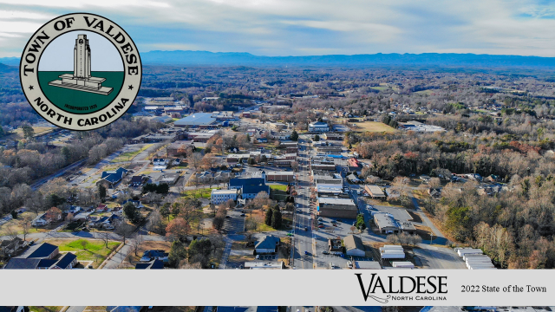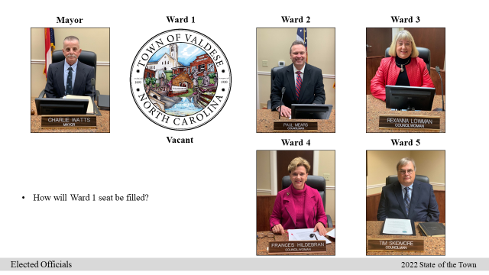
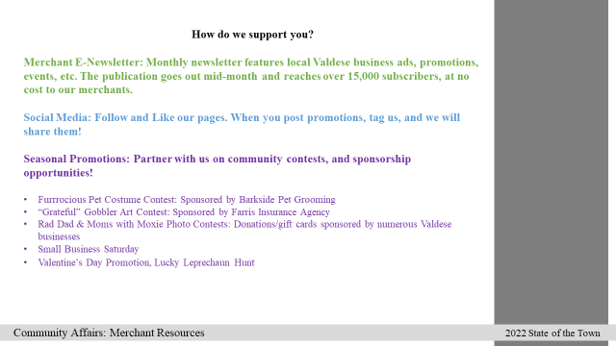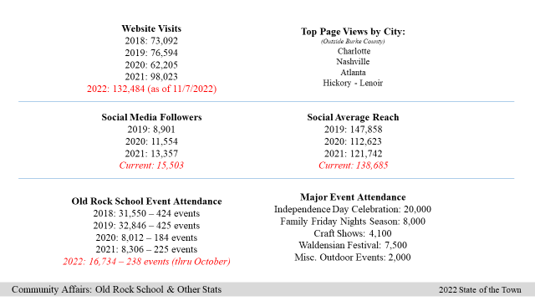
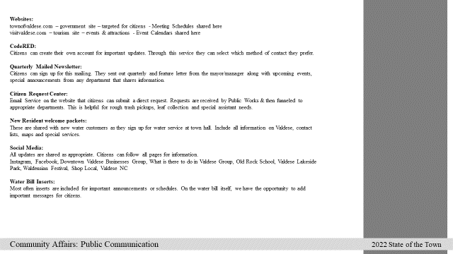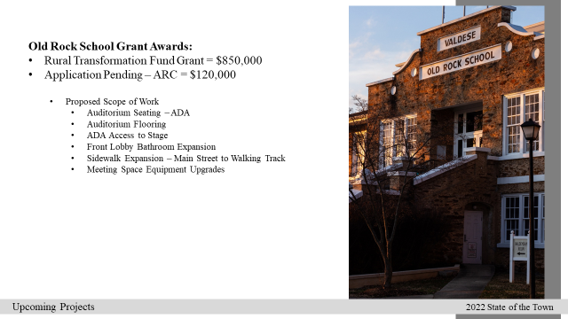
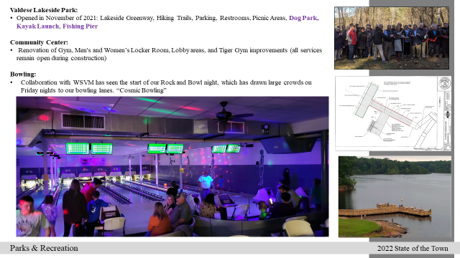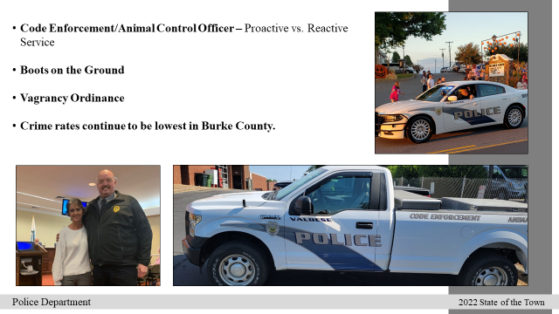
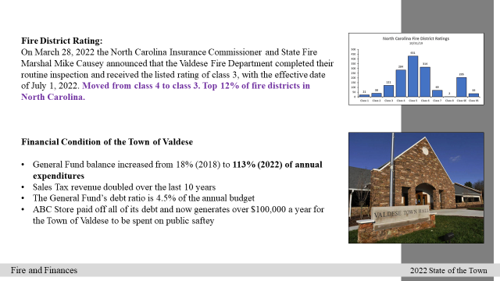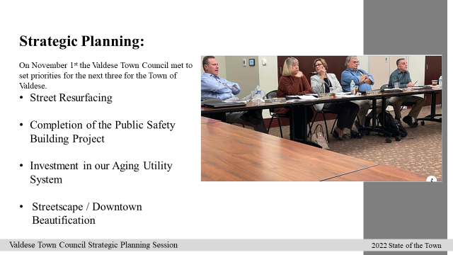
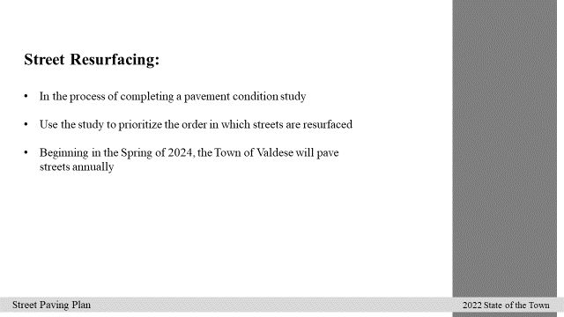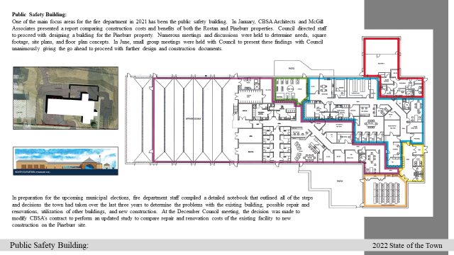
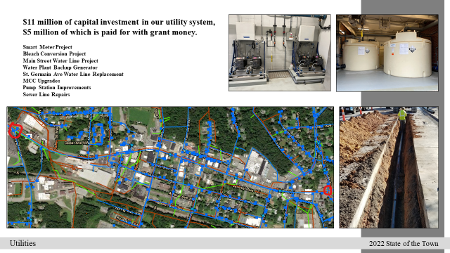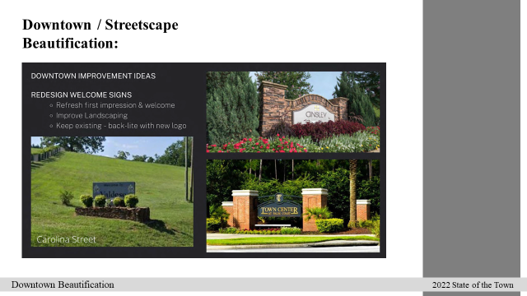
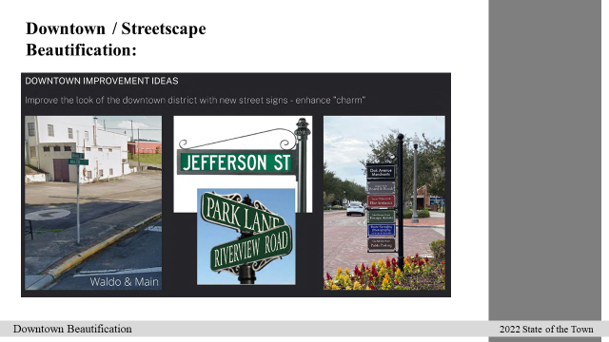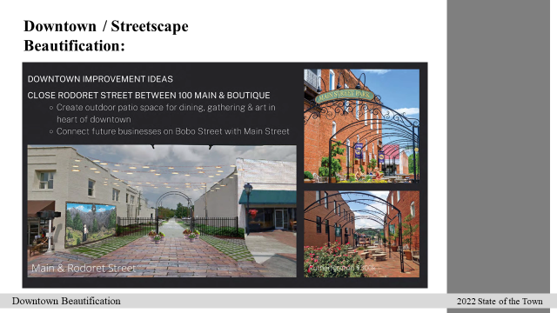

At 7:20 p.m., Councilwoman Hildebran made a motion to adjourn, seconded by Councilwoman Lowman. The vote was unanimous.

The next meeting is a regularly scheduled Council Meeting on Monday, December 5, 2022, 6:00 p.m.

_____________________________ __________________________________
Town Clerk Mayor

jl

